**[CO1, CO2, CO3] (100)**

**INSTRUCTION:**

**A Restaurant Owner plans on creating a point-of-sales system that will allow him to both have a fixed menu and a varying menu. The fixed menu has the following contents:**

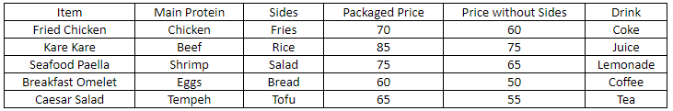

**Upon opening, the system would require a numerical input not less than 2 but not more than 5 indicating how many items will be added to the varying menu. Then will require input for all the fields like the one mentioned. For the price without sides, the program should be able to detect if the value is less than the price with sides. If the price without sides is higher, the program will not accept the input and loop until a correct input is detected.**

**Once the table is completed, the program should allow a simulation of all menu items ordered in the following number of quantity (1,2,3,4,5,6,7,8,9,10) in all items (see sample output) in the same order and display it in a label in the format below:**

**Item Name (Item Initials) (With/Without Sides) x Quantity = Total Price**

**Item Name (Item Initials) (With/Without Sides) x Quantity = Total Price**

**Item Name (Item Initials) (With/Without Sides) x Quantity = Total Price**

**. . .**

**Total Number of Items, Total Price**

**The program's code should be able to have the following in the code:**

**2 or more Arrays**

**2 or More Looping Statements**

**3 or More Functions**

**3 or More Conditional Statements**

**1 or More String Manipulation Statements**

**Sample Inputs and Outputs:**

**Inputs:**

**7**

**\*Error since it is over 5.**

**2**

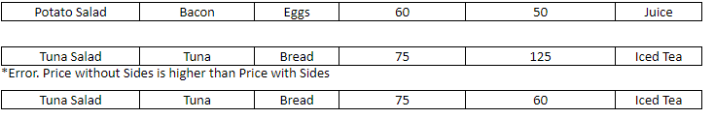

**Output:**

**Fried Chicken (TS) W x 1 = 70**

**Fried Chicken (TS) WO x 1 = 60**

**Kare Kare (KK) W x 2 = 170**

**Kare Kare (KK) WO x 2 = 150**

**Seafood Paella (SP) W x 3 = 225**

**Seafood Paella (SP) WO x 3 = 195**

**Breakfast Omelet (BO) W x 4 = 240**

**Breakfast Omelet (BO) WO x 4 = 200**

**Caesar Salad (CS) W x 5 = 325**

**Caesar Salad (CS) WO x 5 = 275**

**Potato Salad (PS) W x 6 = 360**

**Potato Salad (PS) WO x 6 = 300**

**Tuna Salad (TS) W x 7 = 525**

**Tuna Salad (TS) WO x 7 = 420**

**56 Items, 3515**